Here are some few details when a user makes a self-registration and a self-enrolment to a course
Self-registration of a student-account
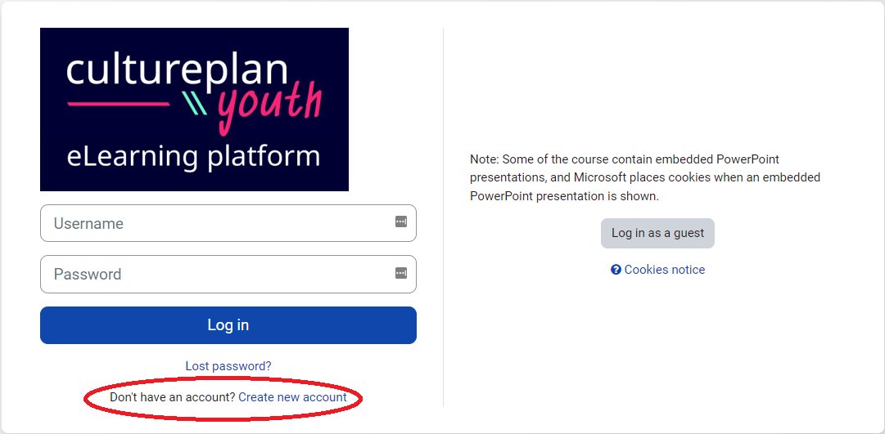
1) Create yourself an account and fill in your name, username, password etc.
2) Hereafter you receive an email from Moodle. Remember to click at the confirmation link in the e-mail.
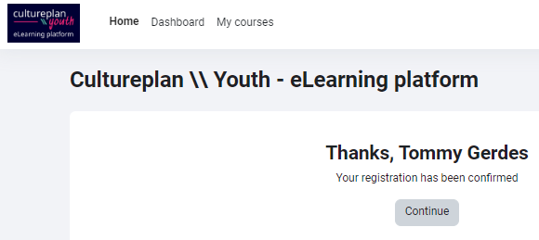
3) After having clicked at the confirmation link in the email, something like this appears.
But when you click at “My courses” you will see that there no courses are assigned to you yet. It is because you have to enrol yourself in the courses.

Self-enrolment to a course
To enrol yourself in a course, select the course from this Mini Moodle list: https://cultureplan-youth-elearning.eu/course/index.php?categoryid=3
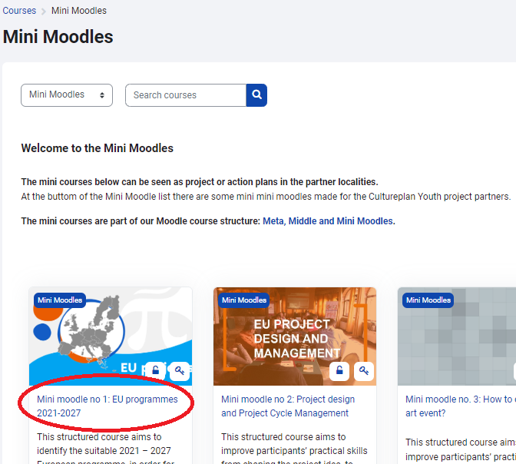

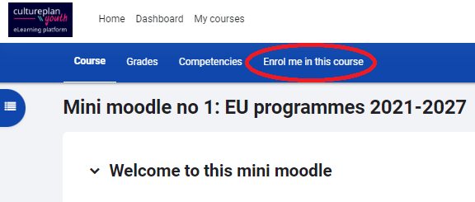
1) When you select a course, e.g. the first one, you will see a link “Enrol me in this course”.

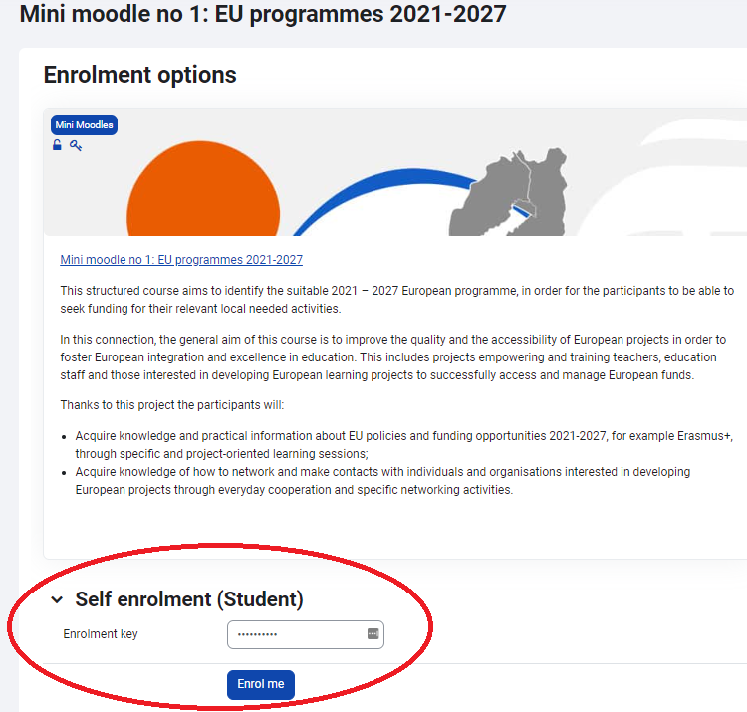
2) Hereafter you have to enter an “Enrolment key”. It is this simple one: cultmoodle
Good luck with the courses.

